Go to host >> Parcel

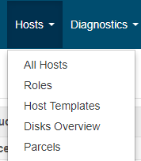

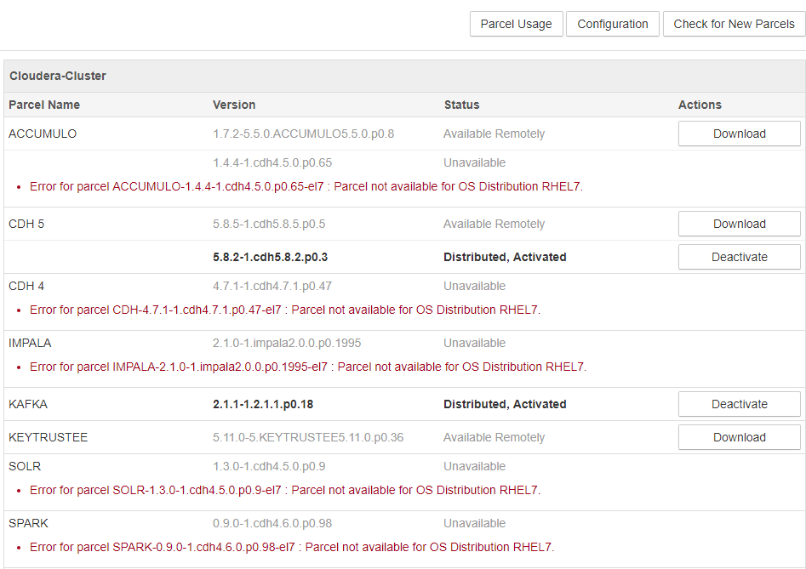

Here I want to add Spark 2.1 version

Click Configuration button

Search parcel for spark2 and add it to Remote Parcel Repository URLS

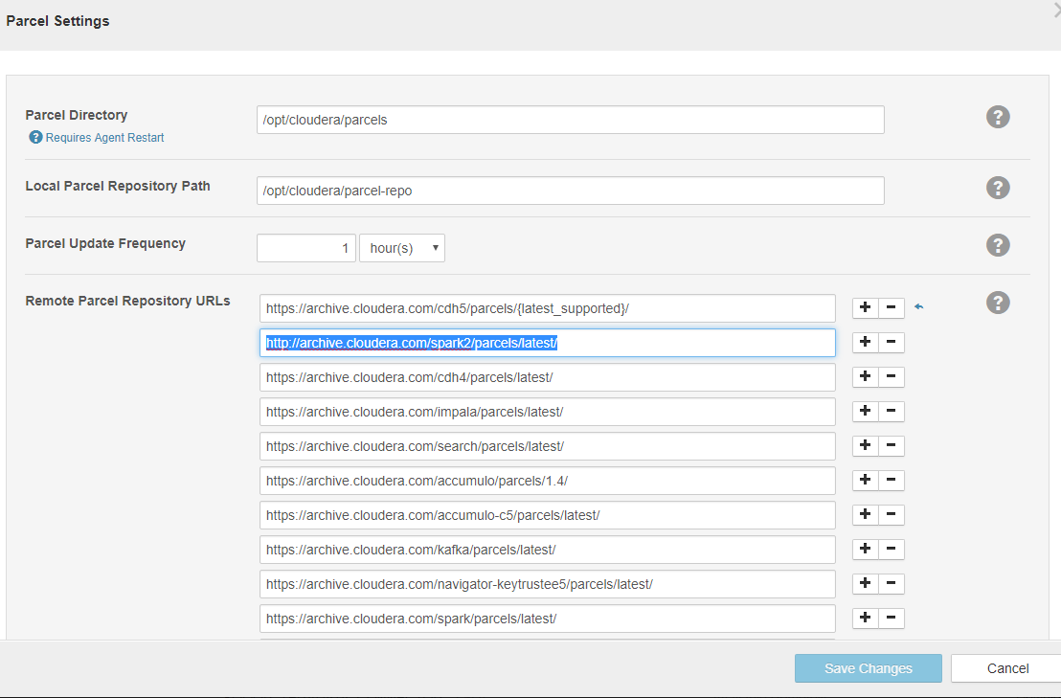

Click Save changes and Click **Check for New Parcels** button

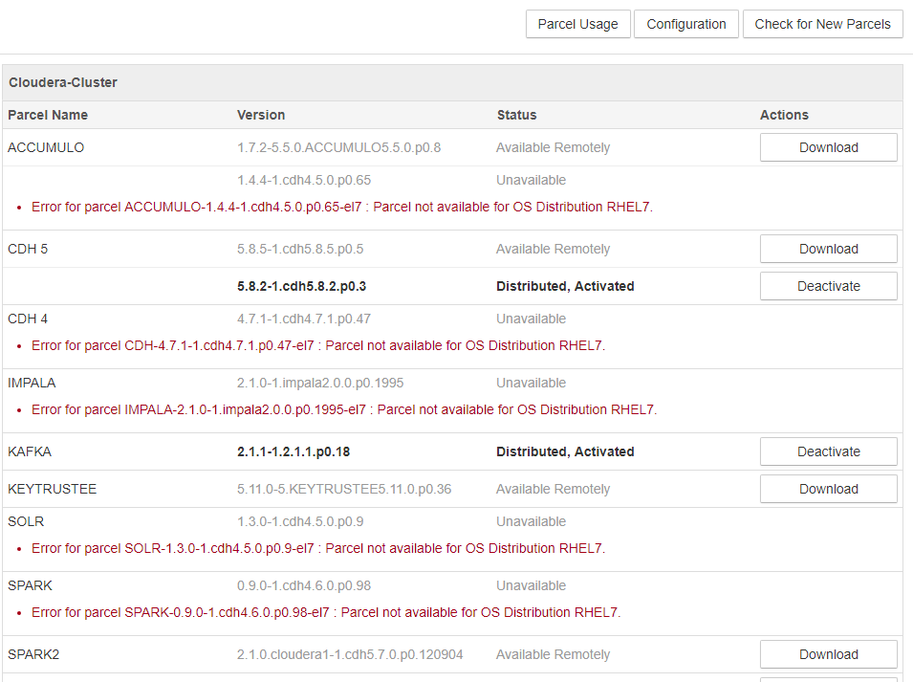

Now you will find SPARK2 service

Click Download



Click Distribute



Click Activate

Now restart stale services

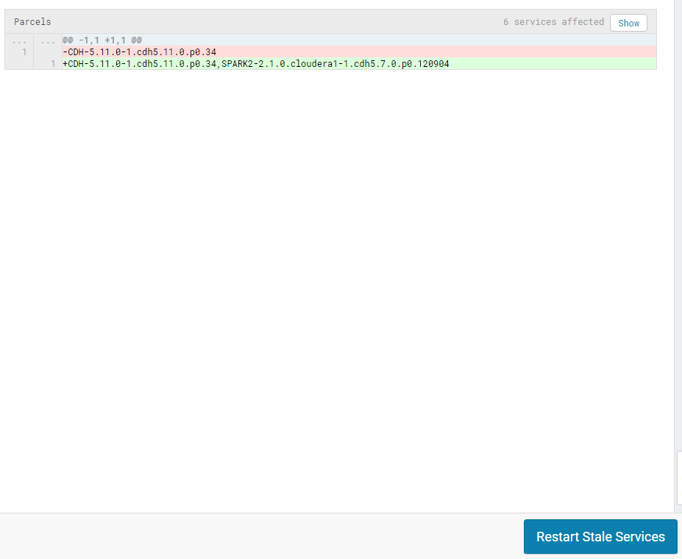

Now you can add new service